Welcome to our booklet regarding our wraparound care opportunities for primary schools in and around Cambridgeshire.
Our intention at Kids Choice is to work closely and personally with schools to provide outstanding wraparound care. We are currently in the process of finding other schools to work with and yours could be one of them!

After-school club

For schools with existing provision in place - (School run, charities, private providers)
If you are a school with one of the above provisions already in place then you might be facing some common challenges such as; financial issues, recruitment difficulties, excessive administration work and sometimes even sub-optimal provision. If this is the case then outsourcing your wraparound provision to an experienced provider might provide an attractive alternative.

In these situations where provision is already in place we often suggest a Transfer of Undertakings, Protection of Employment (TUPE) transfer. This process sees the business/provider change hands whilst the staff and existing structure within the club remains. In doing this we would provide the same familiar adults for the children. We are experienced with this process and have previously used it at Fowlmere Primary School.

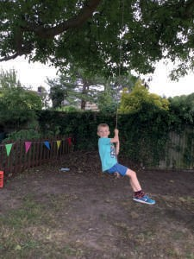
With the TUPE successful, the benefits of an entirely online booking and payment platform for parents, significant investment into the environment and a higher income for the school through our profit share initiative become immediately available. Not to mention additional training for staff, a brand new website & Facebook page, new professional uniform and a high quality provision that the children and parents will greatly appreciate.

For schools who do not already have a provision in place or are looking to end an existing provision we are also happy to recruit for a fresh start.

For either choice the transition takes just one term and is a simple and straightforward process requiring little work from the school.

Our profit share initiative
Our profit share model was created to better support schools financially and we believe this results in a more sustainable and mutually beneficial relationship. We allow each month for a portion of our income to be given to the school based on the number of children attending. This can result in anywhere from £300 - £1,500 per month income.

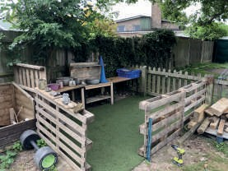
Investing in your school
With any new school that we work with we always make an invesment into environmental improvements. This includes new resources, redecorating, electrical work, plumbing and landscaping. Whilst this is targeted primarily at the after-school club space it often crosses over into the school grounds making an immediate positive impact on a wider scale. We typically invest between £5,000 -
£10,000 within the first year.

Holiday Club
Whilst a holiday club ties in nicely to an existing after-school club, we are more than happy to offer our holiday club provision separately within your school.

The key benefits for hosting our holiday club in your school include; income through our profit share initiative, an added attraction for prospective parents, a significant investment into the environment and a high quality service that parents and children will value and enjoy.

Our holiday club works to the exact needs of the parent with our start times being at 8am and finishing up at 6pm. During this time the children dictate their play and for that reason are happier and more fulfilled at the end of the day. This also ensures every child is catered for as an individual and ultimately reflects school values.

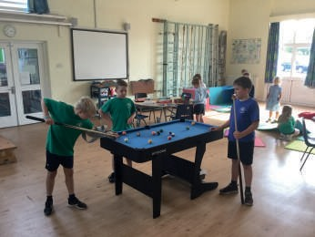Setting up our holiday club at a new school is a straightforward process that can be completed with just one term's notice.

Our personal approach
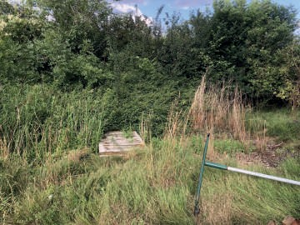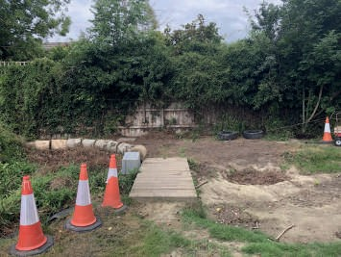It is important that schools we work with understand our intention is to work collaboratively with them and their staff. We get immense satisfaction from parent feedback, watching children play in stimulating environments and supporting schools with the amazing work they do every day. Some of the ways we do this is by improving the play environment (like clearing this overgrown school nature area), access to our resources during school time and supporting school events.

If you have been interested in anything we have to offer here at Kids Choice we would be happy to provide a more personalised and detailed business plan or better yet arrange a meeting to discuss this further. Thank you for taking the time to read our booklet.

Tom Nethercott kidschoiceclubs@gmail.com www.kidschoiceclubs.co.uk

Headteacher (Fowlmere Primary School)
'The club is well-run with all statutory requirements in place and Tom works with the local authority to ensure that the club delivers on the local quality framework. Safeguarding is rigorous with attending younger children being collected from classes at the end of the day and robust collection procedures. Tom is designated safeguarding lead.'

'Children love going to the club. Many are reluctant to go home at the end of a session with the occasional parent sent away by their child so that they can stay longer! The club makes full use of the indoor and outdoor space provided so the children have free choice of a wide variety of activities. In keeping with out-of-school good practice, children are given opportunities to take managed risk and explore play fully. Equally, the club provides space for quieter children, should they wish. The club has established rules for behaviour and they are explained carefully to children. Children are spoken to respectfully. The club is mindful of school food expectations when delivering snack to children.'

'Parents speak warmly of the club, not just because it offers a safe pace for their children whilst they work, but also because they know their children are having a good time. Tom manages all club communication and there are online booking systems which our busy parents are particularly appreciative of.

From a school perspective, the club operates in a self-contained manner. The site is cleared and tidy at the end of each session, and staff put away larger items which may prove a distraction during school time. All administrative tasks are carried out by the club and contact with parents is direct. As the manager, Tom is approachable, responsive and keen to get things right.

New wraparound care opportunities for your school

Our Vision
Some of our parent feedback
'Such a great kids club, my little boy settled in immediately and really enjoyed his days with you. He usually doesn’t like mixing with new environments easily but he loved it. Particular thanks to Tom and Karen who were so kind to him. He will definitely be coming back. Many thanks.'
'Thank you again for transforming after school club, the boys used to dislike it, now they can’t wait to go!'
'Mine declared it 'the best holiday club ever'!
Thank you. '
'Firstly, just a note to say how much the boys enjoyed the club over the summer.
That had such a brilliant time.'
'Thanks for keeping them entertained over the Easter holidays, they both had a brilliant time as usual.'

'To enable every child to experience the power of play in outstanding envrionments.'

Our Values Exceptional people Positive culture Commitment to quality
Outstanding environments

